Chem 116 EXAM 2 (Version C) Spring 2007

Name __________________________ Instructor: Martin Larter
Last First

Page 2 (20 points)

Page 3 (16 points)

Page 4 (14 points)

Page 5 (15points)

Page 6 (20 points)

Page 7 (16 points)

Page 8 (17 points)

Total (118 points)

Percent (100 %)

Joke

Please Name__________________

- Except for alkyl/cycloalkyl groups, CIRCLE and NAME, seven different functional groups in this molecule. (Donation from Baby) (7 pts)

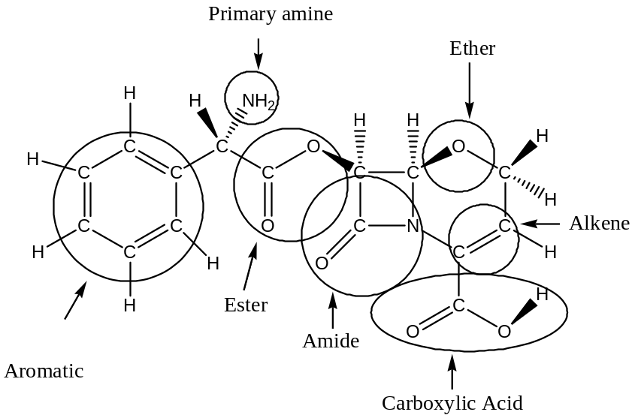

b. Using asterisks (i.e. *) label all of the stereogenic carbons on the diagram below and assign the absolute configuration at each stereogenic carbon as R or S. (11 pts)

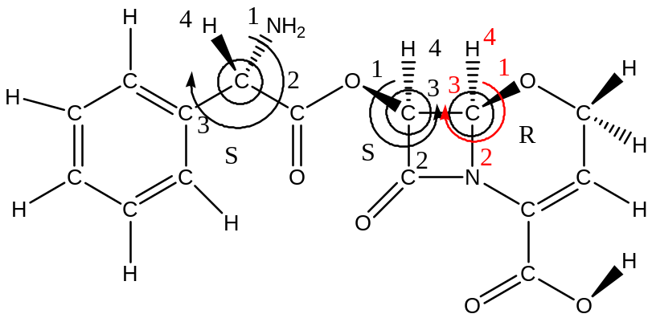

- How many optical isomers will exist for this molecule? __________8__________

- Draw the keto tautomer of 1-penten-2-ol. (2 pts)

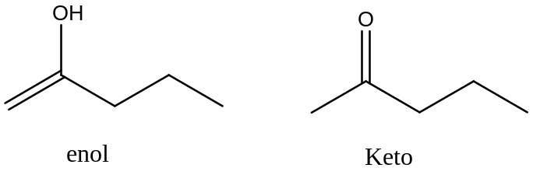

- Rank the molecules in the order of properties indicated and explain. (12 pts)

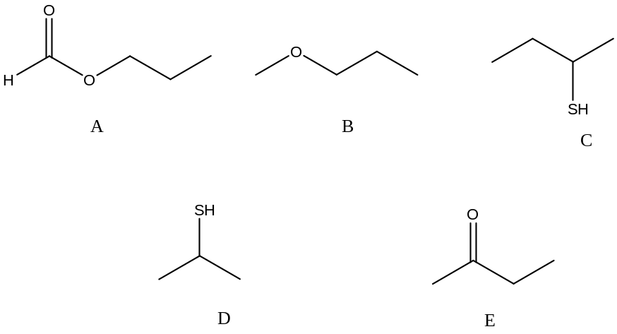

Water solubility

Most __A______ > ___E_____ > ____B____ > ____D____ > __C______ Least

The most soluble is the ester due to its double dipole-dipole interaction, followed by the ketone over the ether due to double bond (more polar) and being more accessible finally the shorter chain thiols Less nonpolar material to drag into solution and that thiols are very weakly polar (weak dipole-dipole interactions) Finally the long chain thiol.

Boiling Point

Most __A______ > ___E_____ > ____B____ > ____C____ > __D______ Least

The highest boiling is the ester due to its double dipole-dipole interaction, followed by the ketone over the ether due to double bond (more polar) and being more accessible finally the longer chain thiols. Thiols are very weakly polar (weak dipole-dipole interactions) but the longer chain allows more surface area to attract fellow molecules by London dispersion interactions. The lowest boiling is the shorter chain thiol.

- Answer the question based on the following structures (4 pts)

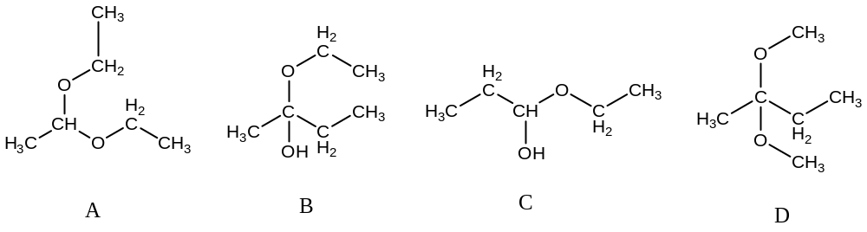

___A___ Which structure is an acetal? ___C___ Which structure is an hemiacetal?

___D___ Which structure is an ketal? ___B___ Which structure is an hemi ketal?

- Complete the following equations, showing the structures for the products formed. All hydrogens should be shown as H's or dashed lines. Write NR if no reaction occurs. (14 pts)

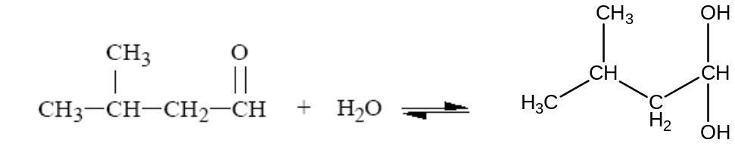

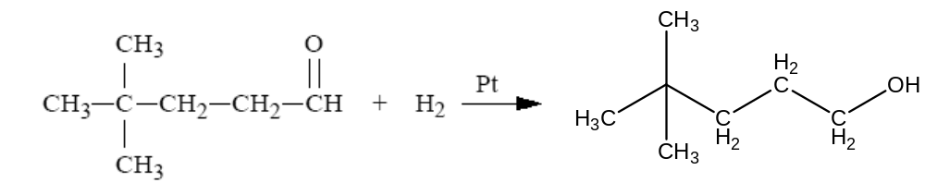

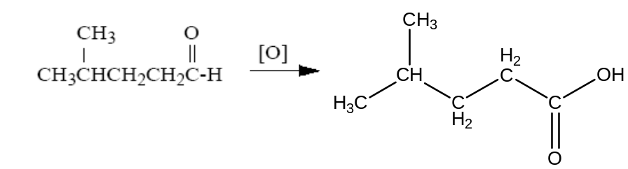
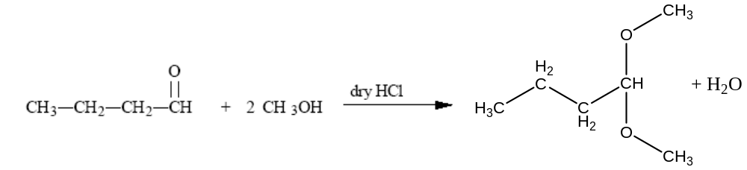

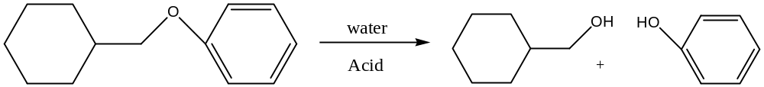

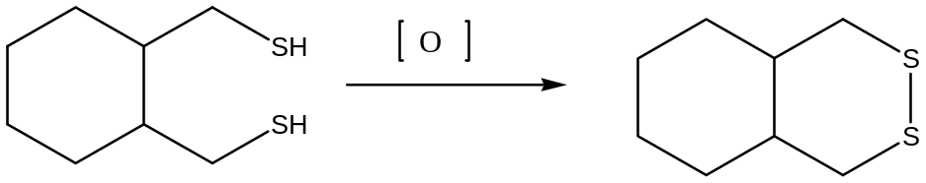

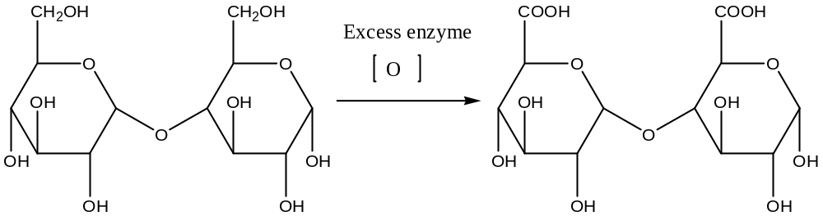

- 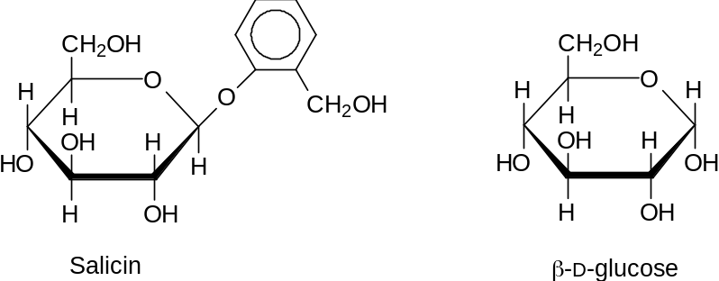The following is the structure of salicin, a bitter-tasting compound found in the bark of willow trees: (3 pts)

The aromatic ring portion of this structure is quite insoluble in water. How would forming a glycosidic (acetal) bond between the aromatic ring and β−D−glucose alter its solubility? Explain your answer.

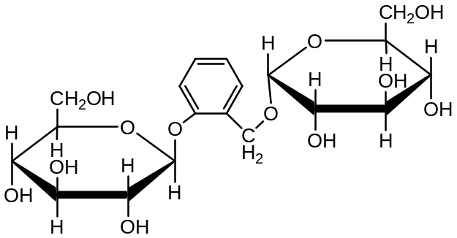
This becomes more soluble. The additional hydrogen bonding on the attached sugar will compensate for the nonpolar aromatic ring making this compound much more soluble.

- Name the following structures using IUPAC or common names (12 pts)

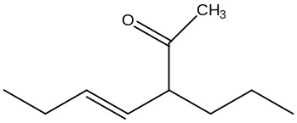
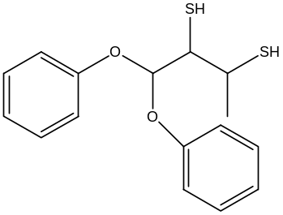

Name__1,1-diphenoxy-3,4-butanedithiol____ Name__Trans-3-propyl hept-4-en-2-one_____

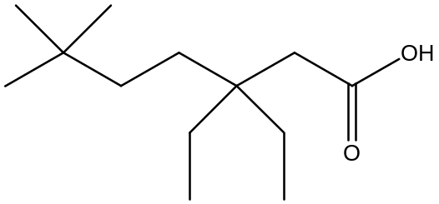
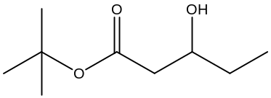

Name 3,3-diethyl-6,6-dimethyl Heptanoic acid__ Name_tert-butyl-3-hydroxy pentanoate__

- Given L-mannose (mirror image of D-mannose) and D-fructose (12 pts)

a. Draw the Fisher structures of L-mannose and D-fructose

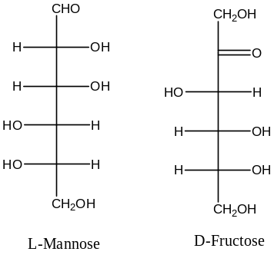

- Draw the structure of the α1, β 2-disaccharide of L-mannose and β-fructose

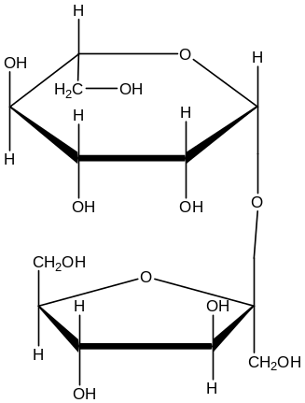

- Compound A C₅H₁₀O gives a negative tollens test. Reduction of A gives B C₅H₁₁O_{H}. Dehydration of B gives two alkenes C and D C₅H₁₀. Compound C is a terminal alkene but D contains a internal double bond. Compound C does not exist as a cis/ trans isomer but D does. Give structures and names for compounds A-D. Show logic. (8 pts)

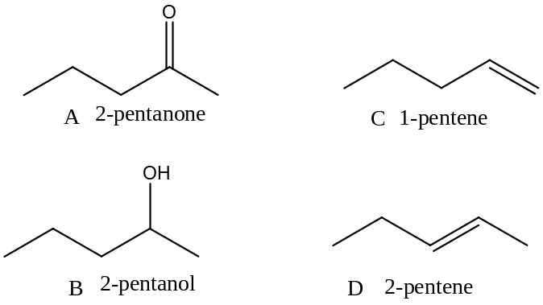

- Fill each of the blanks with a correct term. (10 pts)
    - A compound that contains stereocenters but is not optically active is called___ meso _or achiral
    - __ enantiomer __ are a pair of stereoisomers that are mirror image of each other.
    - A compound is said to be __ optical activie _____ if it rotates the plane of polarized light.
    - A ___ racemic ___ is a mixture of exactly equal quantities of both enantiomers, so that it does not rotate plane-polarized light in either direction
    - the interconversion between the α and β anomers is called__ mutarotation _

    - A disaccharide contains two monosaccharide units joined by a ___ glucosidic bond _ bond.
    - Sugars that react with the Tollens’ reagent to form the silver mirror are called_ reducing _ sugars.
    - A tetrahedral carbon atom that has four different groups bonded to it is called__ steroecenter __
    - The device which measures how much a compound rotates plane-polarized light is a/an__ polarimeter ____
    - A sugar with the OH in the "down" position (on carbon #1 is called___ alpha ___

Terms
a. Cellulose | h. Starch | o. diasteromer
b. Glucose | i. reducing sugar | p. stereochemistry
c. nonreducing sugar | j. polarimeter | q. mutarotation
d. meso | k.steroecenter | r. anomers
e. Aldonic acids | l. achiral | s. alpha
f. Sucrose | m. racemic | t. glucosidic bond
g. Glycogen | n. enantiomer | u. beta
 |  | v. optical activity

- Identify the relationship for following molecules in each pair (same, enantiomers, diastereomers, or structural isomers) show work (6 pts)
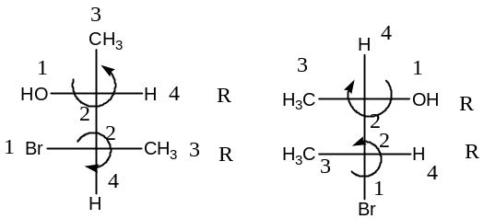
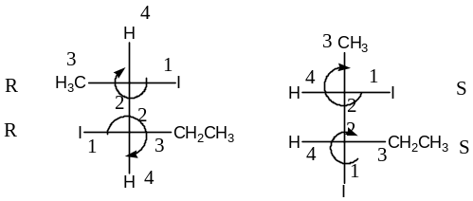

______Same_________________ _______Enantiomers____________________

- Name the two polysaccharides that are the major components of starch, and state the major chemical difference between the structures of these two compounds. (3 pts)

Amylose and amylopectin

Amylose is a straight chain containing alpha 1, 4 glycosidic linkages

Amylopectin is branched and contains alpha 1, 4 and alpha 1.6 glycosidic linkages
- Given the following sugar
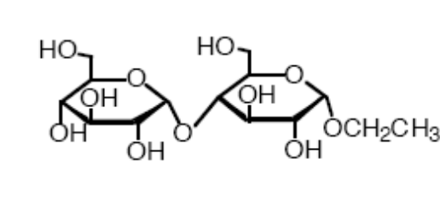
- Is this a reducing sugar, explain (3 pts)
No, the glycosidic linkages are acetal connection. This will not allow the molecule to unfold back into the straight chain. This means there is no free aldehyde that can be oxidized.
- Show the reaction products for the hydrolysis of the following compound. Open chain form (4 pts)
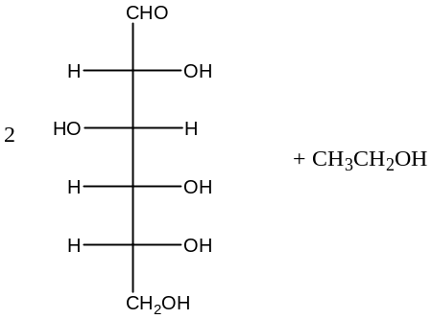

- What chemical test can be performed to determine if hydrolysis occurred and show product for this test. ( 3 pts) Fehlings or Tollens Test

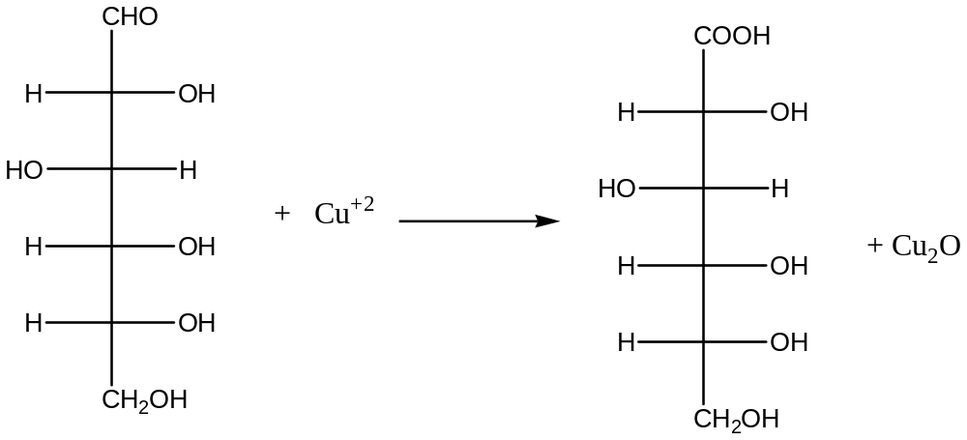

(extra credit). Draw the disaccharide Lactose in chair configuration (Anoter suggestion from Baby) (4 pts)



